NYQUIST

THE CUBIT PROPERTIES - NYQUIST NEGOTIATION
Confidential Information for Attorney for Leonora and Lowell Nyquist
Your clients, twin sister and brother Leonora and Lowell Nyquist, are 75year- old long-time residents of Salem, where your law firm's office is located. (Salem, a city with a population of 300,000, is at the center of one of the fastest growing metropolitan areas in the eastern USA.) Their grandfather Ezra Nyquist, came to the Salem area in the early 1900s and purchased a large tract of land in what was then the primarily agricultural, Salem area. Ezra planted fruit trees on his land and prospered as a farmer. When Ezra died, Nyquist Farms was divided into two parcels, A and B, which were left to Leonora and Lowell, as joint tenants.
Leonora was a high school science teacher until her retirement 12 years ago. Lowell has made his living as a free-lance magazine writer. They have never farmed the Nyquist land, which has lain fallow for years. Neither ever married, and they continue to reside in the handsome house constructed on the property by Abner in 1938. Many of the farms to the west of Salem have given way to urban sprawl, with housing subdivisions, low scale retail and industrial complexes, and office parks. Those changes were accelerated by the completion three years ago of Interstate Route 776 connecting Salem with cities to the west. The area has become very attractive to developers, and for the last few years the Nyquists have begun to think about selling some or all of their Salem land and buying retirement property in Florida.
Two days ago, you were visited by Lowell Nyquist. He told you that he was acting on his own and his sister's behalf and that he had just received a phone call from an attorney with whom you have never dealt in the past, who said that s/he had a client who was interested in "exploring the purchase" of the Nyquist Farms. Mr. Nyquist said that he and Leonora might be interested in pursuing the matter, but that they were about to leave the country for a longplanned vacation. Accordingly, he directed the attorney to contact you.
Mr. Nyquist also told you that he has received several inquiries about selling over the years. Formerly, most of the calls were from builders who were interested in subdividing the property to construct single family houses or condominium communities. Because he and his sister continued to reside on the land and valued their privacy, they were not interested in selling. The completion of the Interstate and the noise and traffic it has brought to the area have, however, caused them to reconsider. The Nyquists also think that the land has now become far more valuable for large-scale development. In recent months, Lowell has been contacted by several major development companies.
In fact, several months ago one such company, Franchetti Development, even sent a representative by the name of Max Mercier to see him. Mercier told Lowell that Franchetti had been "talking to some furniture store" that might be interested in coming to the Salem area and could be a key tenant in a shopping mall, and that his company might be willing to pay "as much as $1.0 to $1.5 million" for the Nyquist land . so long as it could get it re-zoned, convince key tenants to commit to the project and get financing.
Mr. Nyquist felt insulted by Mercier, who he thought had treated him like a dumb rube. First, Lowell believed that the land was probably worth substantially more than the figures Mercier casually tossed out. Second, a half hour's research on the internet convinced Nyquist that the 'furniture store" Mercier had mentioned is Ozepia, the phenomenally successful manufacturer and retailer of inexpensive Scandinavian home furnishings. Ozepia has announced that it is targeting expansion into the Salem area market as a priority corporate goal.
Finally, Nyquist's research indicated that he and his sister wouldn't like
Mercier's company, Franchetti Development, any better than he had liked Mercier himself. Apparently the Franchetti family is a major contributor to conservative right-wing organizations. Leonora and Lowell consider themselves to be liberal environmentalists. They would prefer not to do business with the likes of Franchetti Development, They hope that this new potential purchaser will provide the opportunity to "do good and do well" and also get a better price.
Mr. Nyquist also shared two other pieces of information with you in confidence. After his visit from Mercier and subsequent research that indicated that Ozepia might be coming to Salem, he decided to be proactive and to look for buyers of the property himself. As a result of that initiative, he now has a "pretty firm" commitment from the Constellation Hotel Group to purchase Nyquist Farm B for $975,000 if Ozepia locates in a mall to be constructed on Nyquist Farm A. (An adjacent Ozepia store combined with all of the new office buildings in the western environs of Salem make the Nyquist's Farm B an extremely attractive site for development of a hotel.)
The other information provided by Nyquist is less positive: Apparently in
1917 Ezra, Leonora and Lowell's great-grandfather, became concerned that the United State's entry into World War I might cause problems with the importing of PKX481 , the insecticide he imported from Bavaria to spray his fruit trees. He decided to order several years' supply and to build a series of subterranean concrete "holding tanks" on what was then a remote section of Farm A. (Lowell marked that area with an asterisk [*] on the plan he gave to you.) No use has been made of these tanks since 1923, and Lowell is certain that no one but he and his sister know of their existence. (In fact, Lowell and Leonora only recently learned about the holding tanks when they came upon several old photographs and documents in the attic of their house.) However, Lowell is vaguely concerned about the fact that many of the insecticides used in the 1900's have been found to be carcinogenic. He has no idea if any PKX481 remains in the tanks or if any seeped out over the years or, for that matter, if the concrete holding tanks would cause a builder other problems.
Mr. Nyquist told you that he and Leonora trust you completely and have faith in your ability to get them a good deal. They do not want to be disturbed on their vacation and are willing to give you complete authority to commit to a sale of Farm A. They promise they will not second-guess you. They understand that, as Max Mercier indicated, any developer will want some time to deal with zoning issues and to secure financing and key tenants. They're willing to give a reasonable option period to a substantial developer — in no event longer than 12 months, and 3-4 would be better — so long as the buyer is really serious and they get at least as good a price as Franchetti would pay, (bearing in mind the $975,000 they expect to get from Constellation Hotels for Farm B). That is, you are authorized to agree to a sale of Farm A for any amount over $1.75 million, but you should try to get more if you can.
Lowell and Leonora know that in order to realize the total $2.5 to $3 million they hope for from a sale of their two farms they will have to give a developer an option on Farm A which will keep it off the market for some period of times However, they want you to be sure to push for a "real" commitment from any purchaser. It's all well and good to get a substantial percentage of the purchase price for the option, but the real key is to enhance the likelihood that the sale will ultimately go through. Lowell insists, therefore, that you do whatever you can to assure the purchaser's serious intent to buy. Try to find out if the purchaser is considering (or even committed to buying) any other site(s) in the Grater Salem area. But remember, it's also essential that your client demonstrate to
Constellation that an Ozepia store will be built on Farm A so they can close the hotel deal.
You have set up a meeting with the attorney who called Lowell Nyquist for tomorrow. Prepare for that meeting.

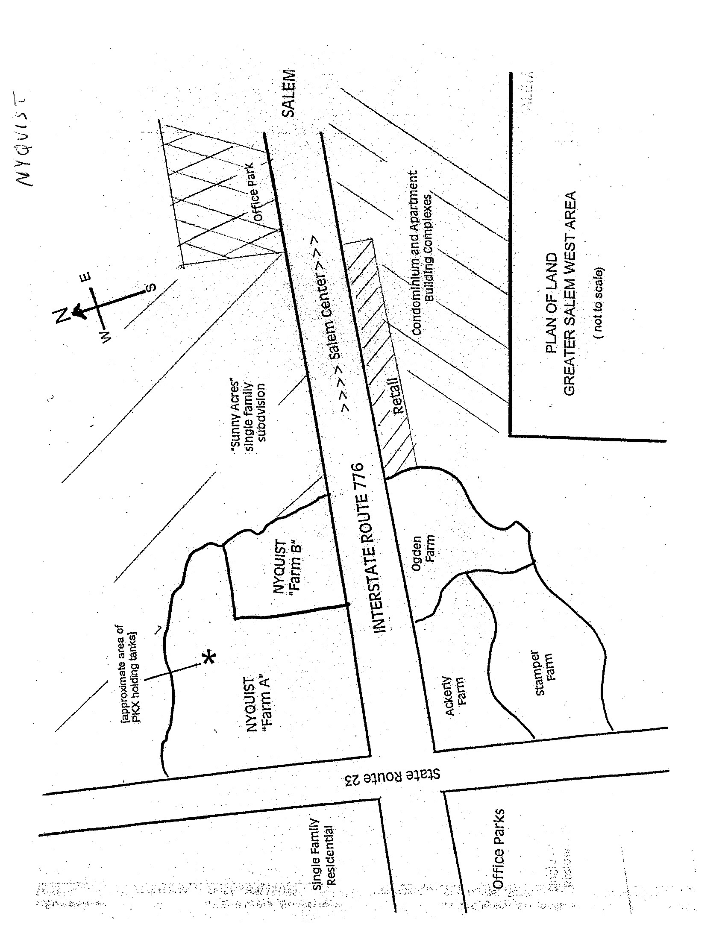

Copyright 2004. Richard M. Perlmutter, Suffolk University Law School. Used with permission.

